## Problem Statement:

Danny is deciding whether he should expand the existing customer loyalty program. We are going to create functional SQL queries to aid his decision making.

## Entity Relationship Diagram & Dataset:

Source: https://8weeksqlchallenge.com/case-study-1/

## Inspiration: https://www.datawithdanny.com/

/* --------------------

Case Study Questions

--------------------*/

-- 1. What is the total amount each customer spent at the restaurant?

-- left join sales with menu. We use left join to reserve the left row of sales and keep customer_id who has been making purchases

-- use sum() to compute the total amount each customer spent

**select** s.customer_id, **sum**(price) **as** amount_spent

**from** dannys_diner.sales s

**left join** dannys_diner.menu m **on** s.product_id = m.product_id

**group by** s.customer_id

**order by** amount_spent desc;

**Output:**

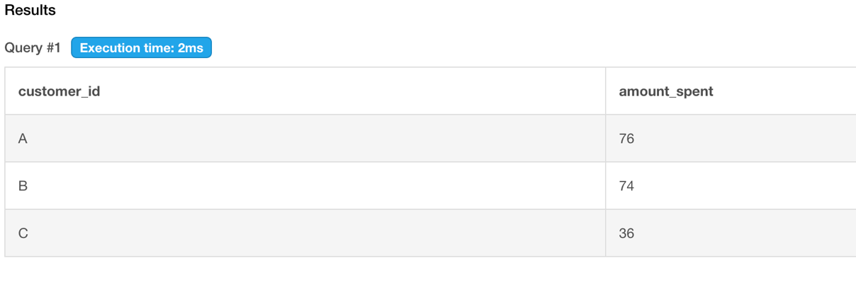

Looks like customer A, and customer B spent the most.

-- 2. How many days has each customer visited the restaurant?

**select** s.customer_id, **count**(**distinct** order_date) total_visit

**from** dannys_diner.sales s

**left join** dannys_diner.members m **on** s.customer_id = m.customer_id

**left join** dannys_diner.menu mu **on** mu.product_id = s.product_id

**group by** s.customer_id

**order by** total_visit **desc**;

**Output:**

Customer B and A visited the restaurant more frequently than others.

-- 3. What was the first item from the menu purchased by each customer?

////

modifying

-- 4. What is the most purchased item on the menu and how many times was it purchased by all customers?

/// modifying

with sales_date

as

(select customer_id, min(date(order_date)) as dt

from dannys_diner.sales

group by 1)

select s.customer_id, s.order_date

from dannys_diner.sales s

inner join sales_date sd

on s.customer_id = sd.customer_id

and s.order_date = sd.dt

inner join dannys_diner.menu m

on m.product_id = s.product_id;

-- 5. Which item was the most popular for each customer?

/// modifying

with

purchase as

(select s.customer_id, m.product_name, count(s.product_id) as total

from dannys_diner.sales s

inner join dannys_diner.menu m

on m.product_id = s.product_id

group by 1, 2

order by 1),

pur as

(select customer_id, max(total) as pop

from purchase

group by customer_id),

final as

(select p.customer_id, p.product_name, pi.pop

from purchase p

inner join pur pi

on p.customer_id = pi.customer_id

and p.total = pi.pop)

select * from final;

-- 6. Which item was purchased first by the customer after they became a member?

with

cte as

(select s.customer_id, s.order_date, s.product_id, m.join_date,

min(order_date) over(partition by s.customer_id) as first_date

from dannys_diner.sales s

inner join dannys_diner.members m

on s.customer_id = m.customer_id

where m.join_date <= s.order_date)

select c.customer_id, order_date, first_date, product_name

from cte c

left join dannys_diner.menu m

on c.product_id = m.product_id

where order_date = first_date

order by c.customer_id;

-- 7. Which item was purchased just before the customer became a member?

-- find the product bought before customer become member

**with** cte

**as**

(**select** s.customer_id, s.order_date, s.product_id,

**min**(order_date) **over**(**partition** **by** s.customer_id) **as** first_order_date

**from** dannys_diner.sales s

**inner join** dannys_diner.members m **on** s.customer_id = m.customer_id

**where** order_date < join_date)

**select** customer_id, product_name

**from** cte c

**left join** dannys_diner.menu m **on** c.product_id = m.product_id

**where** order_date = first_order_date

**order** **by** c.customer_id;

**Output:**

Customer 1 ordered sushi and curry, whereas customer 2 ordered curry before he/she became the member.

Ah ha! Sushi and curry are the favorite items in the restaurant

-- 8. What is the total items and amount spent for each member before they became a member?

**with**

sales_members **as**

(**select** m.customer_id, s.product_id

**from** dannys_diner.members m

**inner join** dannys_diner.sales s **on** m.customer_id = s.customer_id

**where** order_date < join_date)

**select** c.customer_id, **count**(m.product_id), **sum**(price)

**from** sales_members c

**left join** dannys_diner.menu m **on** c.product_id = m.product_id

**group by** c.customer_id

**order by** c.customer_id;

**output:**

Customer B bought 3 items and spent 40. customer A spent less at 25 with 2 items.

Ah ha! Customer B could be a very potential customer

-- 9. If each $1 spent equates to 10 points and sushi has a 2x points multiplier - how many points would each customer have?

-- create a case statement to compute the point

**select** s.customer_id,

**sum**(**case**

**when** m.product_name = 'sushi' **then** m.price * 10 * 2

**else** m.price *10

**end**) as point

**from** dannys_diner.sales s

**inner join** dannys_diner.menu m **on** s.product_id = m.product_id

**group by** s.customer_id

**order by** customer_id;

**Output:**

We got the total point for client A is 860, client B is 940, client C is 360

-- 10. In the first week after a customer joins the program (including their join date) they earn 2x points on all items, not just sushi - how many points do customer A and B have at the end of January?

-- Query:

-- create a timeline table that contains join_date, and first_week(after become member)

-- left join timeline table with sales and menu

-- create a case statement to compute the point

**with**

timeline **as**

(**select**

customer_id,

join_date,

join_date + 6 as first_week,

**extract**(month from join_date) as month

**from** dannys_diner.members)

**select** t.customer_id,

sum(**case**

**when** product_name = 'sushi' **then** (price * 2 * 10)

**when** order_date **between** join_date

**and** first_week then (price * 10 * 2)

**else** price * 10

**end**) as january_points

**from** timeline t

**left join** dannys_diner.sales s **on** s.customer_id = t.customer_id

**left join** dannys_diner.menu m **on** m.product_id = s.product_id

**where** month = 1

**group by** t.customer_id

**order by** t.customer_id;

**output:**

